Circles of Concern, Influence and Control

Template

Circle of Concern

Circle of Influence

Circle of Control

There are 2 questions to complete for this task.

1. Using the example of COVID-19, brainstorm all the issues that belong to your Circle of Concern, your Circle of Influence and your Circle of Control.
   1. Circle of Concerns – what are all your concerns in relation to COVID-19?
   2. Circle of Influence – what are you able to influence in relation to COVID-19?
   3. Circle of Control – what are you able to control in relation to COVID-19?

Record your responses within each circle.

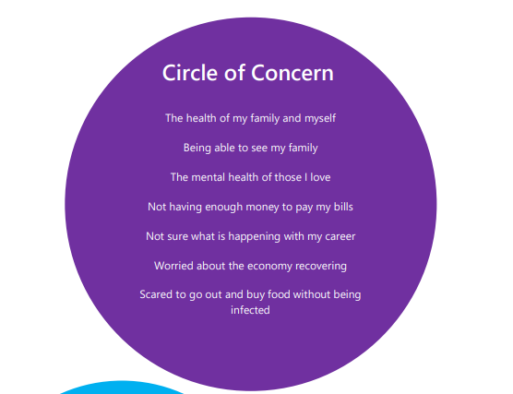

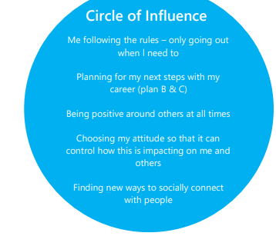

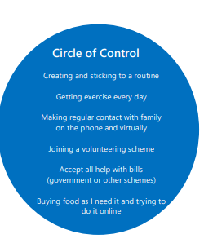

Circle of Influence

Circle of Control

2. Identify how this model can be helpful in dealing with challenging situations.

1. This can help me reframe my thinking when things feel out of control and I’m feeling overwhelmed by change or challenges I’m being confronted with.
2. I need to accept that I can’t control everything. I also know that sometimes my circle of concerns is vast. Some of these things are outside of my control and some are not. I can only control certain things and should focus my attention on working with that and in areas that I actually do have influence over. If I really can’t do anything about something, I probably shouldn’t waste my time, effort and worry about it. It is very useful to complete these circles when approaching new and different challenges (especially like COVID-19). It helps to write this all down and reflect on where I should focus my energy.
3. When I am dealing with change, uncertainty or challenge and thinking about certain issues, I am going to ask myself, “Is this in my circle of concern, control or influence?” and then work out how best to deal with that issue realistically and constructively.